**Assignment 3 Report**

**Contact Information:**

Name: Ved Ranade

Email ID: [vranade1@binghamton.edu](mailto:vranade1@binghamton.edu)

**Contents:**

1. Purpose of the Assignment
2. Method – Algorithms Used

2.1 Formula for calculating eight-point Discrete Cosine Transform

2.2 Formula for calculating eight point Inverse Discrete Cosine Transform

2.3 Formula for converting HSI to RGB

1. Running the program
2. Results
3. Bug Report
4. **Purpose of the Assignment:**

The purpose of completing this assignment is to understand concepts of color image processing and image processing in the frequency domain, along with the following concepts:

* RGB and HSI color models
* Discrete cosine transformation
* Hough transformation

**2. Method - Formulae Used:**

2.1 Formula for calculating eight-point Discrete Cosine Transform:

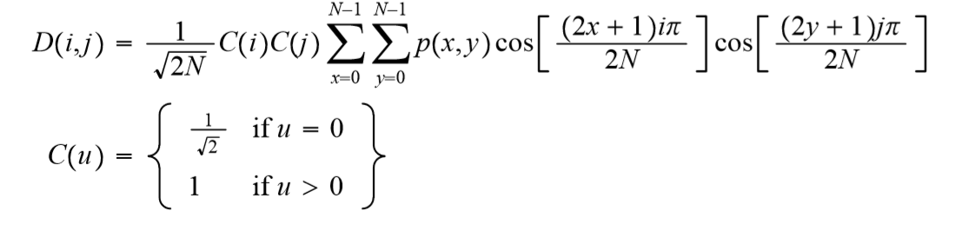

2.2 Formula for calculating eight point Inverse Discrete Cosine Transform:

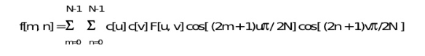

2.3 Formula for converting HSI to RGB:

Hue:

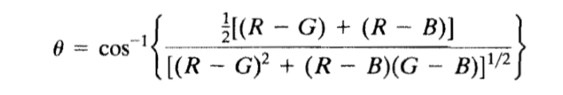

Saturation:

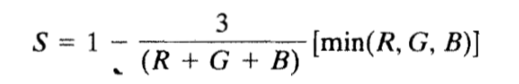

Intensity:

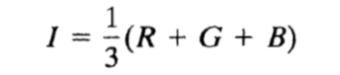

1. **Running the program:**

***OpenCV version 3.3 was used for the execution of this assignment***

Step 1: Unzip the uploaded files to a location

Step 2: Open the Command Prompt in Windows

Step 3: Execute the Solution3.exe executable file using the command prompt and provide an image file full path as a command line argument

Step 4: On hitting Enter, the program will display the next output

1. **Results**

Screenshots for question (II), 2D image compression section of the Programming section:

Input Image:

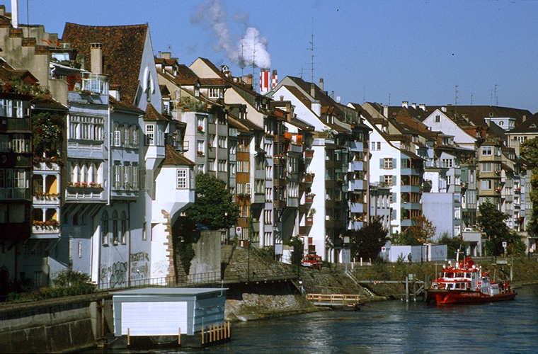

Intensity image I:

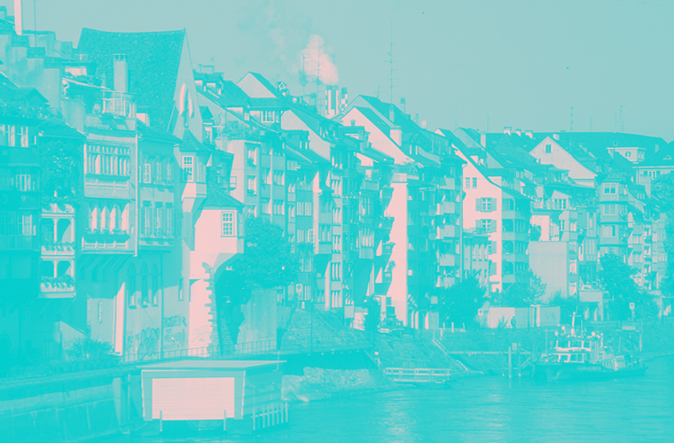

Frequency domain image F:

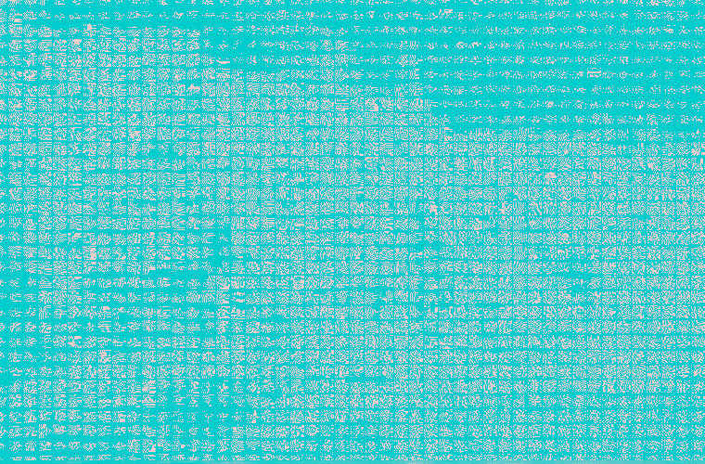

Image D1 (Zoom to observe DC component):



Image D2:



Image R1:



Image R2:

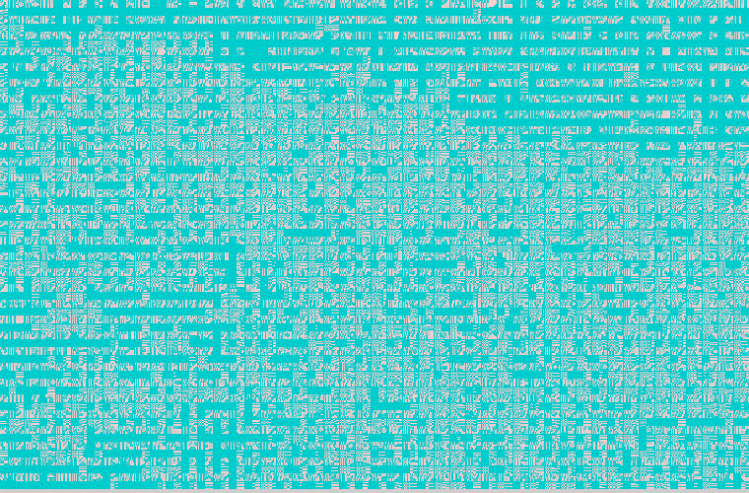

Image R1 has a higher degree of blur as compared to image R2. This is because image R1 consists of only the first DCT coefficient in each 8x8 block, whereas image R2 consists of the first nine DCT coefficients in each 8x8 block.

1. **Bug report**

Parts that are not complete:

* Part B: Color based image segmentation
* Part C and Part D (Extra questions)